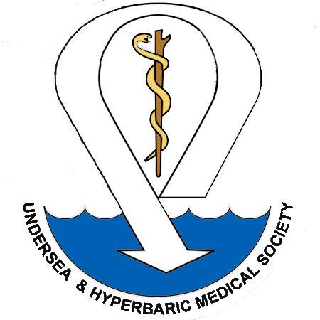
Undersea & Hyperbaric Medical Society
Application for Membership

631 US Highway 1, Suite 307 Phone 1-877-533-UHMS (8467) / (919) 490-5140
North Palm Beach, FL 33408 Fax (919) 490-5149
U.S.A. Email: uhms@uhms.org
Thank you for your interest in joining the Undersea & Hyperbaric Medical Society. Our membership is committed to research, sound treatment, and education in the fields of diving medicine, hyperbaric oxygen therapy and wound care. All members will receive the pdf version of Undersea & Hyperbaric Medicine Journal (Hard copies can be purchased at an additional fee), our Membership Newsletter, Pressure, and discounts on all UHMS meetings, publications, and library services. So that we can best serve all our members, please complete the information below as completely as possible. Thank you for becoming a part of our membership community!
Last Name: |  | First: |  | MI: |  | Suffix: |  | Degrees: |  | Birthdate:

Please list preferred MAILING ADDRESS: If using Business Address, please include Organization Name.
Address
City
State/Province/Int’l County |  |  | Daytime #
Zip/Postal Code |  |  | Fax #
Country |  |  | Email
* Email is required: this is where notices will be sent
Please choose a membership level:
 |  | INDIVIDUAL LEVEL |  | Dues | Qualifications
 |  | Regular (R) |  | $325 | Regular Members of the Society shall be physicians or doctorate-level health care professionals (MD, DO, PhD, DPM, DDS, or equivalent). This category will include those Associates waived by the BOD as exceptional cases.
 |  | Regular, Government/Military /Academic (RG) |  | $250 | Members shall be doctorate level health care professionals in active government service, or doctorate level life sciences professionals in academic or government service.
 |  | In-Training (IT) |  | $140 | Members shall be physicians (MD or DO) currently in a formal post-graduate training program (internship, residency or fellowship or post-graduate doctoral trainee)
 |  | Associate (A) |  | $85 | Hyperbaric technicians, registered nurses, physician assistants, nurse practitioners, undergraduate students, diving supervisors, certified scuba instructors, or other hyperbaric or diving personnel with specialized technical or research backgrounds but who do not possess the academic background for Regular Membership can become Associate Members of the Society. Regular Members (retired) who are 65 or older and are not working can also fall under this category; however they will not have voting rights. Associate Members are not entitled to vote or hold office for the Regular Membership positions on the Board of Directors, but are eligible to vote and hold office for the Associate positions on the Board.
CORPORATE LEVEL |  |  |  | Dues | Qualifications: Corporate Partner membership is available to corporations or companies that are supportive of the mission, purpose and goals of UHMS and wish to support our organization financially.
 |  | Corporate Diamond |  | $5,500 | This level includes five (5) individual Memberships, emails sent by UHMS on behalf of the corporate member, banner displayed on the corporate, vendor and the UHMS home pages.
 |  | Corporate Platinum |  | $3,500 | This level includes four (4) individual Memberships, emails sent by UHMS on behalf of the corporate member, banner displayed on the corporate and vendor pages.
 |  | Corporate Gold |  | $2,500 | This level includes three (3) individual Memberships, emails sent by UHMS on behalf of the corporate member, banner displayed on the corporate page.
 |  | Corporate Silver |  | $1,500 | This level includes two (2) individual Memberships and banner displayed on the corporate page.
 |  | Corporate Bronze |  | $500 | This lever receives its logo displayed on the corporate page
Medical Specialty:
Are you a member of American Medical Association? |  |  |  |  |  |  |  | YES  YES |  | NO
Are you Board Certified? |  |  |  |  |  |  |  | YES  YES |  | NO
If yes, which Board are you currently certified with?
Membership Qualifications:
 | As a member of the UHMS I agree to abide by the Constitution and Bylaws of the Undersea & Hyperbaric Medical Society. A copy of these documents may be viewed at our website. To assist us in upholding these standards, please sign and date this application and return it to the UHMS Headquarters. PLEASE CHECK BOX. A copy of these documents may be obtained from the Society office or viewed at our website.
PAYMENT INFORMATION
 |  | Check/Money Order enclosed (Must be made payable to UHMS and be USD only)
 |  | Visa |  |  | Master Card |  |  |  |  |  |  |  | American Express |  |  |  |  |  |  |  |  |  |  | Diners
Card Number |  |  |  |  |  |  |  |  |  |  |  |  |  |  |  |  |  |  |  |  |  |  |  |  |  | Expiration Date |  |  |  |  | *Security Card Code
Name on Card |  |  |  |  |  |  |  |  |  |  |  |  |  |  |  |  |  | Billing Zip Code |  |  |  |  |  |  |  |  |  |  | Card holders Signature
____ AUTO RENEWAL-SIGN ME UP: We are now offering a recurring payment (subscription) request that will be submitted to our selected payment processor (Authorize.net). If the request is successful, this membership will be automatically renewed on the last day of the membership period until the recurring payment is cancelled. Membership payment receipt emails will include a link for the member to cancel the auto-renewal.
ONLINE REGISTRATION available by going to: www.uhms.org

